Jenkins Assignment 9 using pipeline
Create 3 repository and add index file in each branch then create instances like master, slave-1 , slave-2 then set up java , tomcat , and open Jenkins dashboard
Step -1 do setup
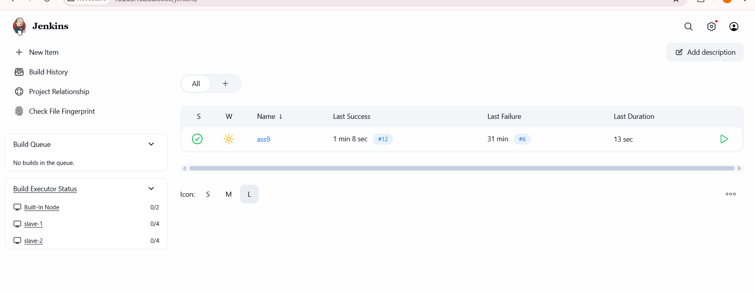
Step 2 - then create 3 repo in github and setup github webhook goto manajge Jenkins and then goto setting and add
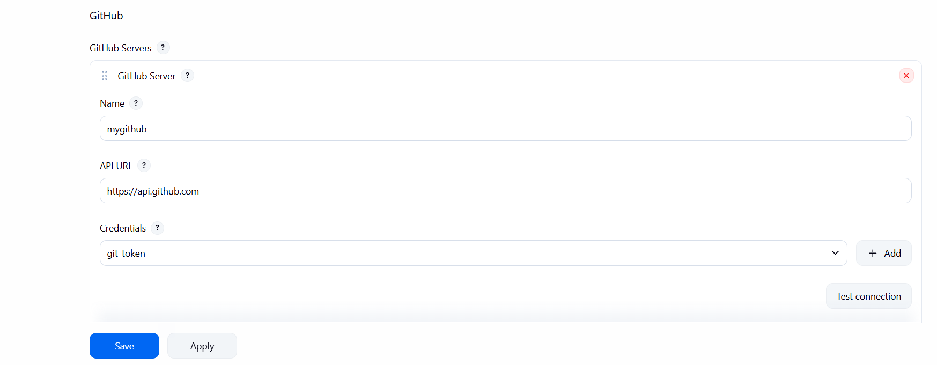
Step 3 – goto each repository setting and go inside webhook then add webhook add url
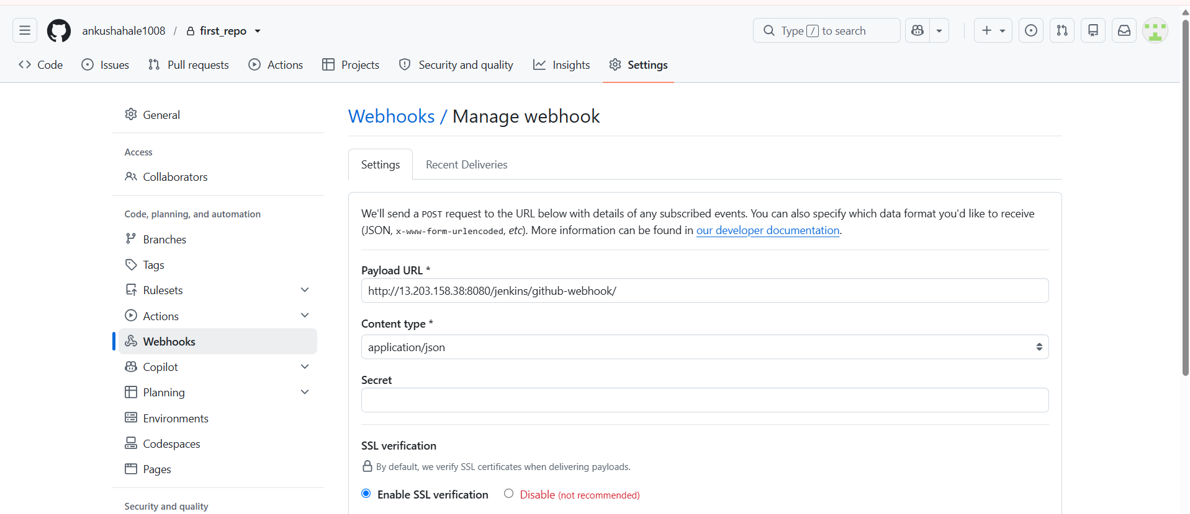
Step 4 – create job and add code
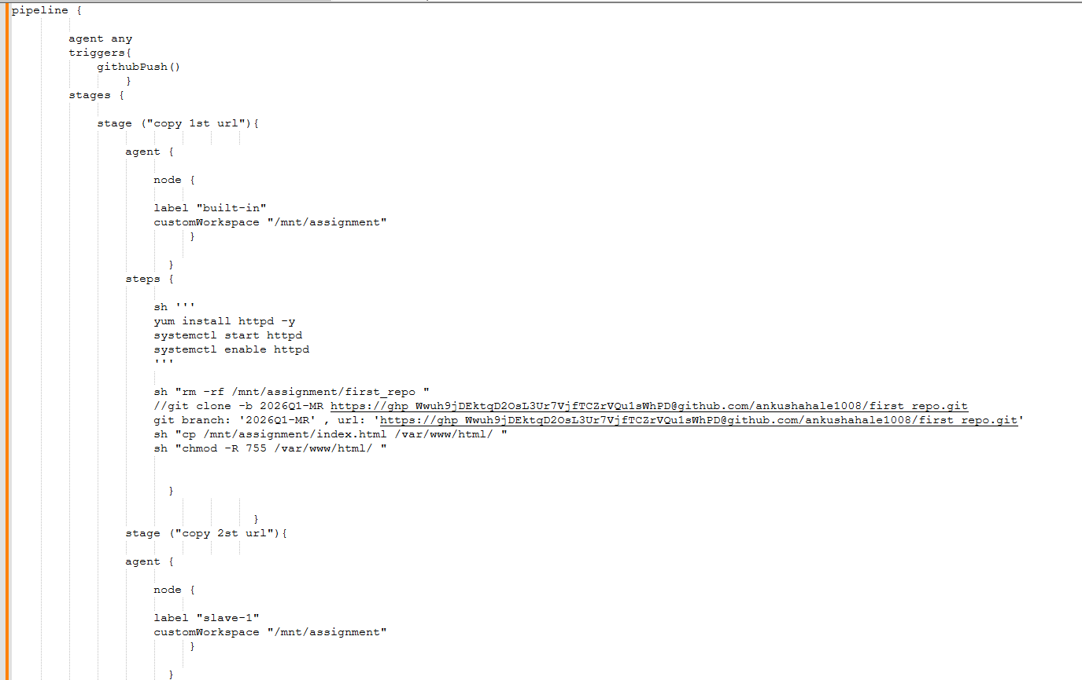
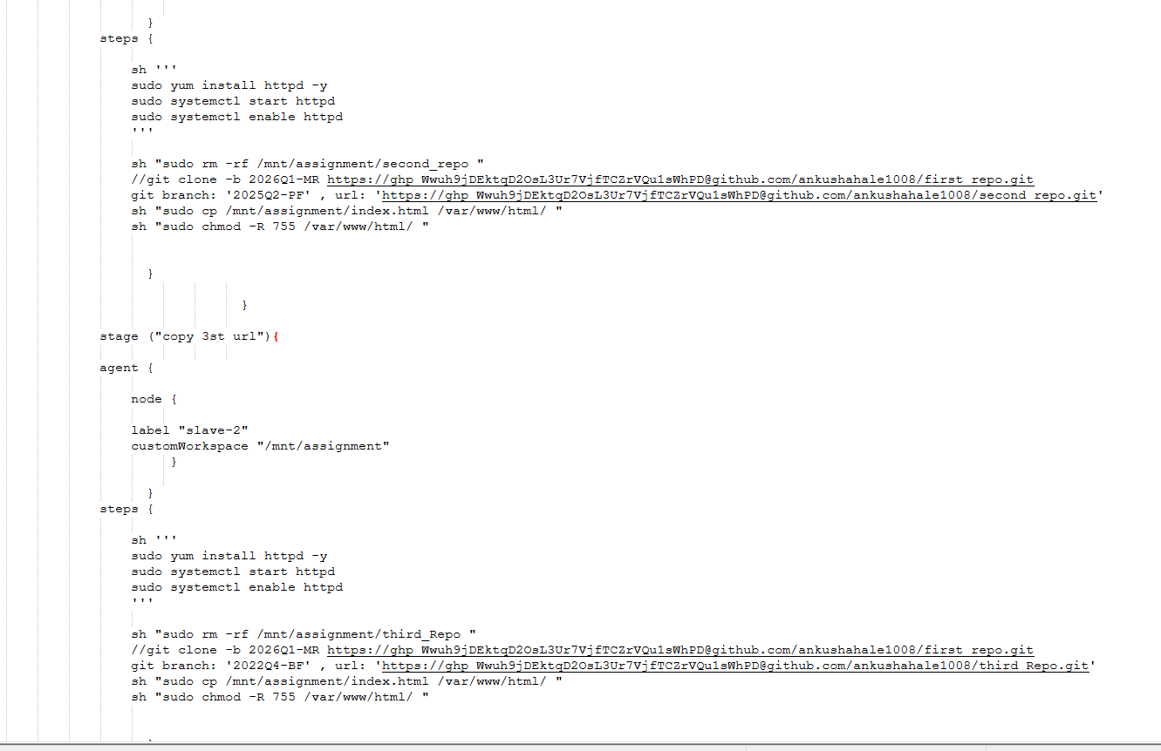
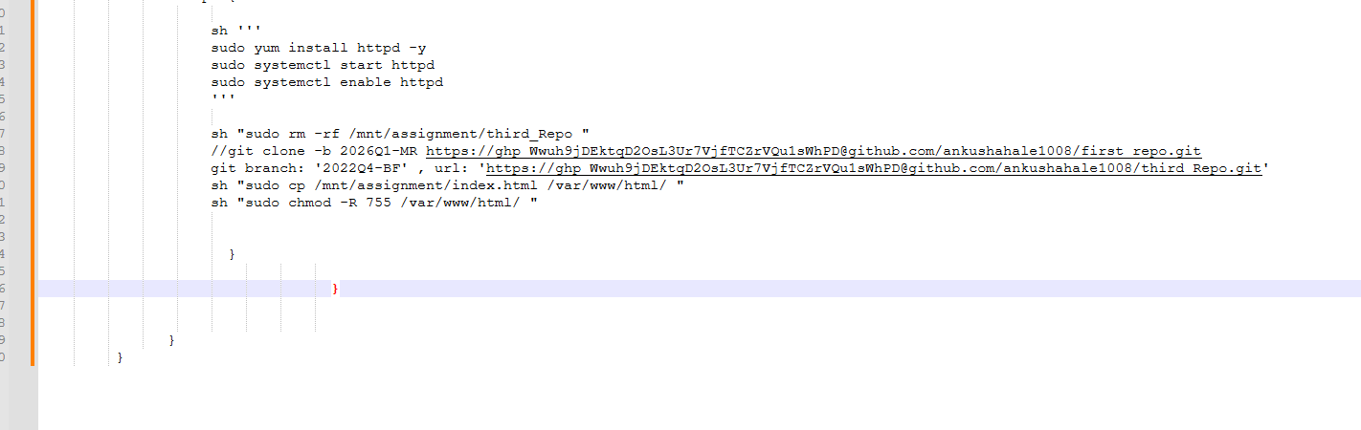
Step 5 -go any repository and make changes then new build immediately start
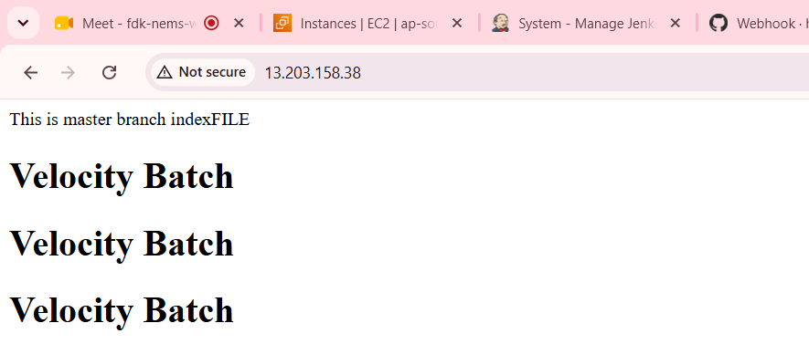
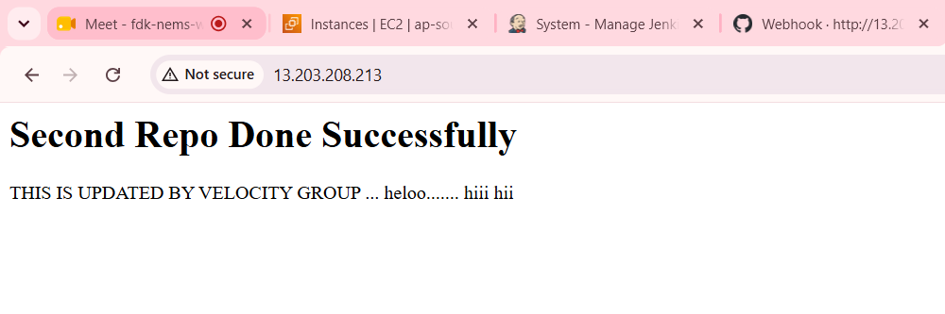
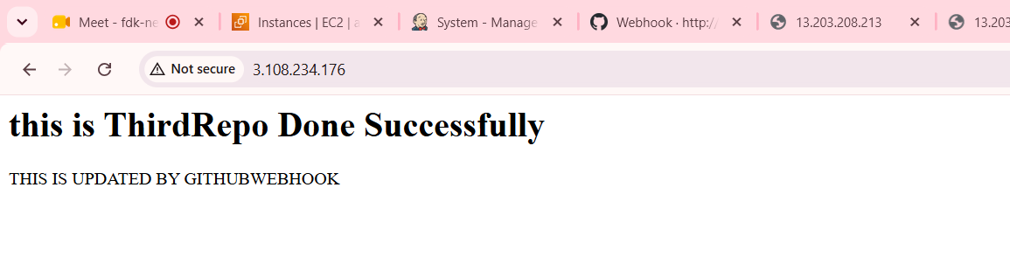
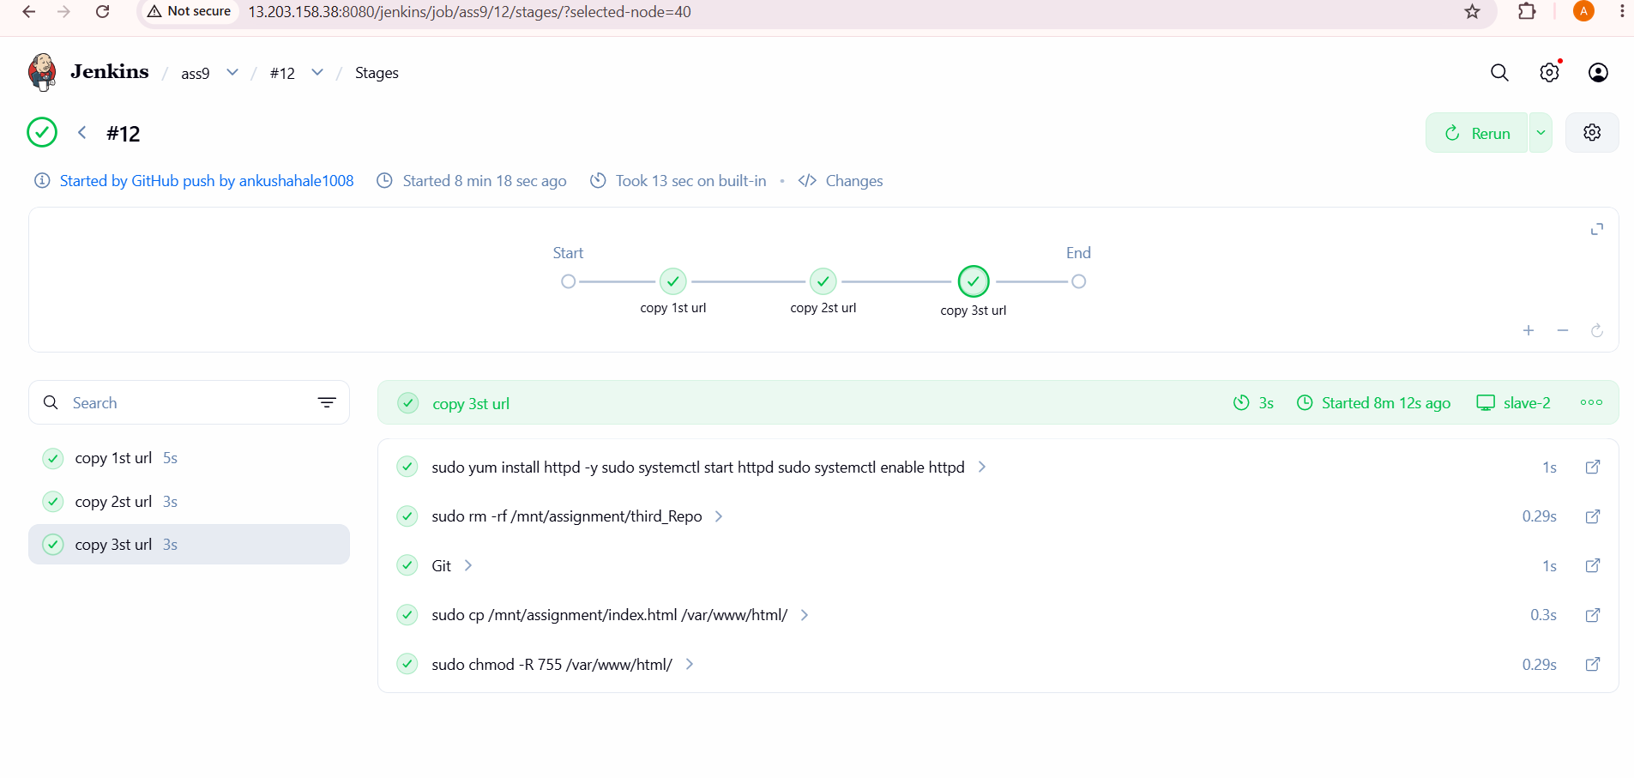
Done Successfully.

